
St. Paul’s Church of England Primary School

Meet the Inclusion team
HANNAH KEYZER – SENCo - Senco@st-pauls-addlestone.surrey.sch.uk
A Special Educational Needs Coordinator (SENCo) is a qualified teacher responsible for the day-to-day operation of a school's special educational needs (SEN) policy. They coordinate additional support for pupils and act as the key point of contact for parents, staff, and external agencies.
- All SEND related work/queries
- Edukey & provision map/SEND paperwork
- Designing and delivering interventions in the classroom & managing the Intervention Timetable
- Leading, supporting and training staff members in SEN provisions, including SEN Induction
- Leading LSA Meetings & Appraisals
- Lunchtime Play Lead modelling/ support
- STIPS, SALT, EP and other outside agencies link
- Inclusion Team Weekly Plan
- Support with behaviour in school
- Nurture group lead
- Support for parents at home with SEN issues such behaviour, routines
- Identifying and assessing pupils’ needs and observing them in the classroom
- Designated Teacher for LAC children


LEANN GRIGGS – Family Liaison Officer – FLO@st-pauls-addlestone.surrey.sch.uk
A School Family Liaison Officer bridges the gap between home and school, providing pastoral support to pupils and families to improve attendance, behaviour and wellbeing. They often act as a dedicated point of contact for parents, conducting home visits, connecting families with external services, and addressing barriers to learning. The DDSL assists the primary DSL in managing child protection, student welfare, and safeguarding operations.
- Deputy Designated Safeguarding lead (DDSL)
- Parental support-long & short term
- Early Help Assessments
- Attendance Monitoring: Tracking attendance data and working directly with families to improve attendance rates.
- Develop and implement attendance improvement plans and promote positive attendance practices
- Young Carers group leader
- Supporting with financial difficulties e.g. food banks, school uniform difficulties, breakfast & after school club places for vulnerable pupils
- Signposting for additional support for families, referrals and direct work where required
- Offer emotional support to parents, & help children cope with transitions
- Half Termly Newsletters
- Online safety aspect of Safeguarding
- Working with external agencies to support families
- School-Home Partnership: Facilitating communication and fostering trust between teachers and parents.


JO JONES – Inclusion & Pastoral Officer - IPO@st-pauls-addlestone.surrey.sch.uk
A school Inclusion & Pastoral officer plays a critical pastoral and disciplinary role in maintaining a safe, calm, and inclusive learning environment. They act as the primary bridge between teachers, students, and parents, proactively managing student conduct, de-escalating classroom disruptions, and implementing targeted interventions to help students regulate their emotions. The DDSL assists the primary DSL in managing child protection, student welfare, and safeguarding operations.
- Deputy Designated Safeguarding lead (DDSL)
- CPOMS & Safeguarding Training for staff
- Support in school with behaviour
- Parental support (short term)
- Early Help Assessments
- MHST support with Deputy Head
- Support with home issues such as behaviour challenges/ routines, for all families
- Working with external agencies to support families
- Delivering emotion and behaviour based intervention
- Coordinating parental workshops
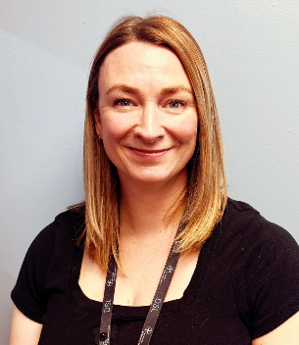

HOPE GREEN – SEN Administration Assistant – Parents@st-pauls-addlestone.surrey.sch.uk
A school SEN administration assistant supports the SENCo and teaching staff to ensure students with special educational needs and disabilities (SEND) receive the necessary provisions to thrive. They bridge the gap between administration, classroom support, and student welfare. Speech and language support plays a crucial role in helping students who struggle with communication, speech sounds and social interaction.
- SEN Assessments
- Support SENCo with STIPS, SALT, EP, outside SEND agencies admin including all paperwork
- SEND & Safeguarding admin (including scanning, letters, filing)
- Diagnostic Evaluations: Using standardized assessments to evaluate a child's receptive (understanding) and expressive (speaking) language.
- Goal Setting: Creating specific, measurable short- and long-term targets to be included in Individual Education Plans (IEPs) or Education, Health and Care Plans (EHCP)
- Ongoing Monitoring: Tracking pupil progress and adjusting therapy plans as the child develops
- 1:1 and Group Sessions: Delivering targeted clinical interventions to help pupils with specific speech sounds, stammers, or language delays.


LISA MCKENNER – ELSA - Parents@st-pauls-addlestone.surrey.sch.uk
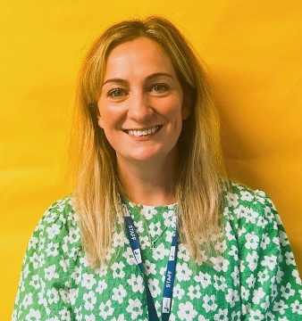
An ELSA (Emotional Literacy Support Assistant) in a school is a trained specialist teaching assistant who provides bespoke emotional and social support to pupils. ELSAs help children recognize and manage difficult emotions, develop resilience, and build vital social skills so they can thrive academically and socially.
- 1:1 Emotional literacy & confidence. Helping children identify, name and understand their emotions so they can respond to trigger constructively.
- Self Esteem & confidence: Using goal setting and positive self-talk to boost a pupil’s belief in their abilities.
- Social & Friendship skills: Teaching children how to communicate effectively, manage conflicts, and build meaningful relationships.
- Navigating loss & Change: Supporting children through specific, difficult lift events like bereavement, family separation, or trauma.
- Managing Anxiety: Providing a safe, judgement-free space and teaching practical coping strategies for pupils struggling with worries.
- Young carer group leader

JANE BAGGS – Art & Emotions learning support - Parents@st-pauls-addlestone.surrey.sch.uk
Art and emotions in schools are foundational for Social-Emotional Learning (SEL). They provide vital, non-verbal outlets for students to process stress, build resilience, and develop empathy. By integrating creativity into the curriculum, schools create environments that actively support student mental health, self-awareness, and overall behavioral well-being.

‘Expressing Emotions through Art’ interventions, through mediums such as:
- Clay Therapy
- Sensory Art
- Self portraits

The arts can promote social- emotional learning in pupils in various ways including;
- Self-Expression
- Empathy
- Communication

- Conflict resolution
- Self-regulation
- Self-reflection

